**PAGE 1**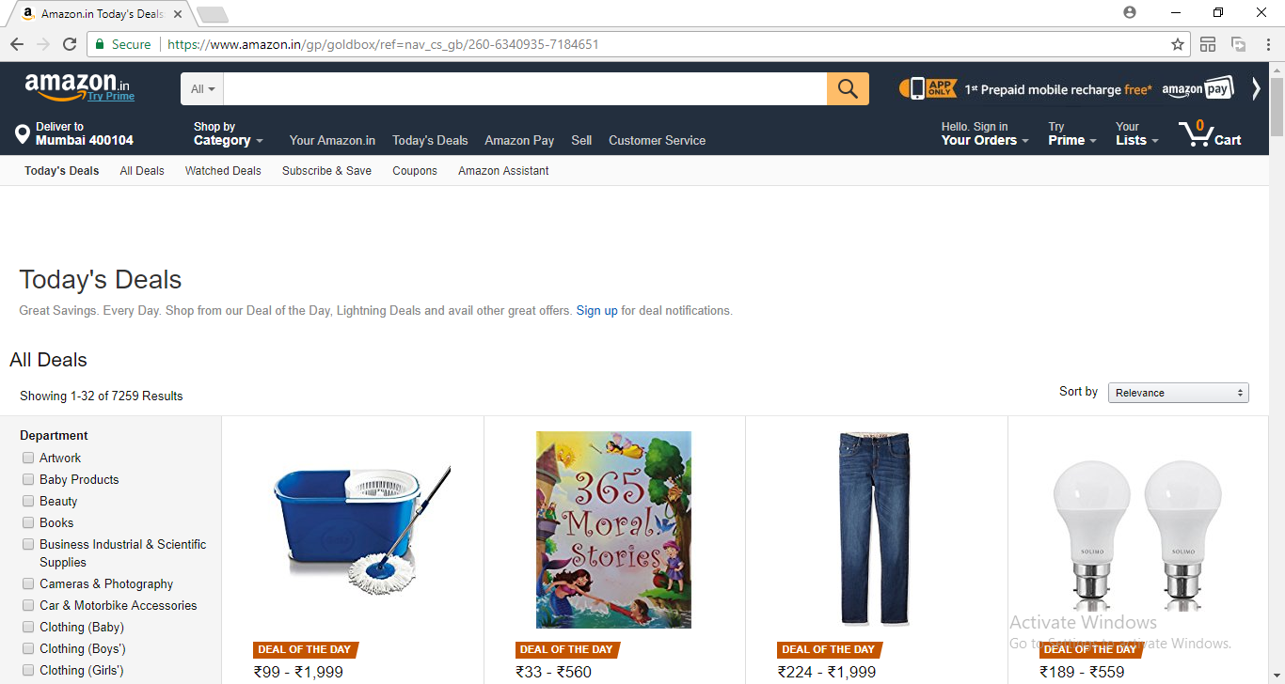

**On Click of the Above Highlighted Text, go to Page 2**

**PAGE 2**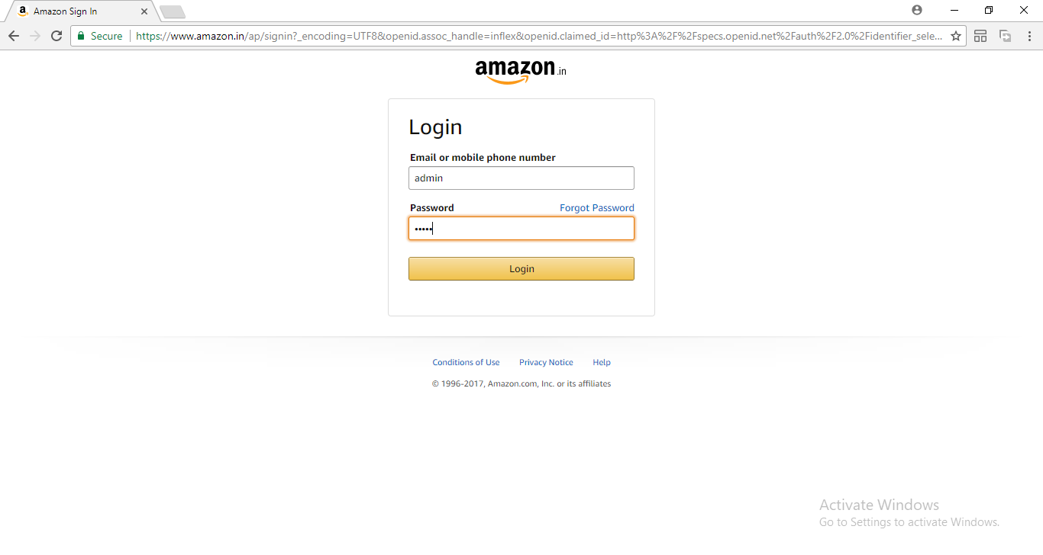

**Sign in with Username: admin and Password :admin. Authenticate them and then, go to Page 3**

**PAGE 3**